The Princess

and the Pea

by Hans Christian Anderson

Illustrated by Dorothee Duntze

miserable

sloshing

dreadful

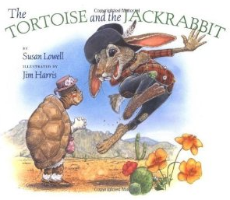The Tortoise and the Jackrabbit

By [Susan Lowell](http://www.amazon.com/Susan-Lowell/e/B001IXM9ES/ref=sr_ntt_srch_lnk_1?qid=1348427261&sr=1-1)

slithered

bolted

skedaddled

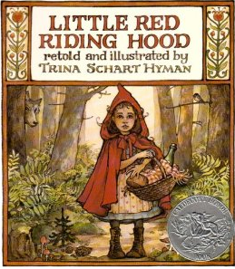Little Red

Riding Hood

Retold by Trina Schart

scrumptious

zigzagged

adores

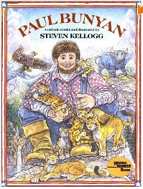Paul Bunyan

Retold by Steven Kellogg

urge

thunderous

longingly

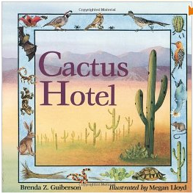Cactus Hotel

By Brenda Z. Guiberson

gnaws

beckon

glisten

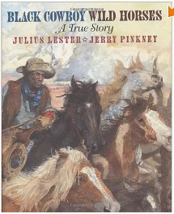Black Cowboy

Wild Horses

By Julius Lester

intently

remorse

aimlessly